Image retargeting using depth assisted saliency map
F. Shafieyana, N. Karimia,⁎, B. Mirmahboubb, S. Samavi, S. Shirani
(seam-carving)

- Energy function: saliency map, depth map, and gradient map
- And algorithm to adaptively assign proper weights to these three maps
- Calculate a switching threshold based on energy ma

The gradient is sensitive to energy change in object edges and causes deformations.

Methods: saliency, diffusion map, saliency + gradient(edge detector, face detector, and line detector), combine seam carving with cropping and scaling, depth map, using just noticeable difference (JND) model for seam selection, and wrapping based methods.

Proposed method
This switching threshold is used to properly decide when to switch from seam carving to scaling when the image size is being reduced.
- An image needs more information from a saliency map if it has an important object in the foreground.
- While depth map is more effective in preserving salient regions in an image with important objects scattered in different depths.

Procedure: scattering map -> energy map -> choose a switching threshold
The depth map is input
Saliency map reached from hierarchical saliency detection method. This algorithm extracts three image layers of different scales from the input image and then computes saliency cues from each of these layers. Then, a graphical model is used to fuse these cues into one single map and produces the final saliency map
Gradient map: It should be mentioned that higher values of gradient map do not necessarily mean the more importance of this map, This algorithm applies Canny edge detection with different thresholds in each scale and averages them. Final edges are the maximum of all detected edges in different scales. Then we use thresholding to remove less important edges and prepare the map of only important edges for the next step of the algorithm that calculates scattering of the gradient map. We refer to this map as MSMT.

Scattering map:
Saliency Map determines important regions more exactly if salient objects are more concentrated in the scene and are less scattered.
- SM is most important.
- Otherwise, if salient objects are scattered in various depths of the image, then the saliency map does not contain sufficient information to estimate a proper energy map. ----> using the depth map.
- On the other hand, important edges in the image usually belong to object boundaries. Therefore, the existence of various objects in the scene leads to more scattering in image edges and GM plays a more important role in the estimation of image pixel importance.

Importance coefficient estimation:
From masks that generate using SM, GM, and DM calculate important coefficients for those.
We expect that SM and DM are related together and some important regions are shown in both of them. We propose an algorithm to consider this overlap between SM and DM.
First, we define a binary Mask/S, D and MaskS, and maskD using [17]
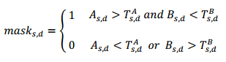
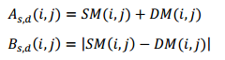
mask/S and mask/D ---> are produced by applying thresholding
Important Coeficients:
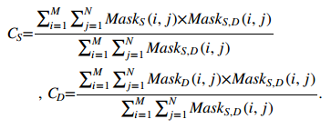

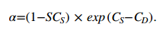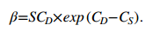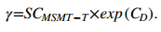
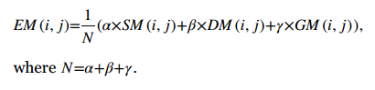
Switching threshold computation:
sometimes many important objects are scattered all over the image and most parts of the image have high energy. In this case, the seam carving method may select and remove some high-energy parts of the image to reach the desired target size, causing considerable distortions.
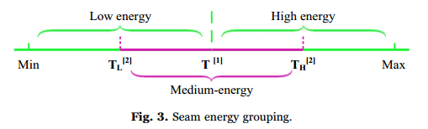
On the other hand, using only scaling method, for high reduction percentages, will cause serious shape deformations in salient objects. If we detect the low-energy parts of the image and carve them before scaling, we can reduce the distortion that is caused by image scaling.
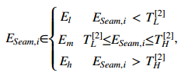
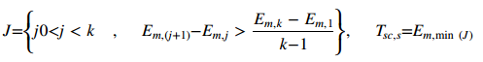
Seam carving + scaling:
Seam carving is continued until the desired target size or threshold T/sc,s is reached.
Then, if we did not reach the size of the target, we will bring the image to this size by scaling.

Failure cases:
In some cases, scaling alone works better than the algorithm presented in this paper.
This usually happens when an important object is scattered throughout the image.

